DEVELOPMENT AND IMPLEMENTATION OF SOLVENT EXTRACTION PROCESS FOR COPPER RECOVERY FROM AMMONIA LEACH SOLUTIONS

By

1Alexander Tsekov, 1Todor Angelov, 1Georgi Savov and 2Bas Nauts

1Iontech 2000 JSC, Bulgaria

2Attero, The Netherlands

Presenter and Corresponding Author

**Alexander Tsekov**

alexander@ionteching.com

ABSTRACT

The Atero/Elemetal-Ssolvent Extraction/Electrowinning (A/E-SXEW) pilot plant is a hydrometallurgical processing plant located at the Attero’s site Deurne in the southeast of the Netherlands. The copper Pregnant Leach Solution (PLS), obtained via ammonia leaching of bottom ash, reports to the solvent extraction (SX) section where copper is recovered and cathode copper is produced in the electrowinning (EW) circuit using stainless steel blanks. The solvent extraction section consists of 4 (four) mixer-settler units: 1 (one) for extraction, 2 (two) for washing and 1 (one) for stripping. The wash stages are employed in order to minimize transfer of ammonia and impurities between extraction and stripping. The plant design is based on the use of conventional mixer-settlers. The EW section produces 135 kg per day of cathode copper with five 9s (99.999 percent copper) quality. The A/E-SXEW pilot plant is designed to operate at low and intermittent flow rates for 6 months in order to obtain sufficient data for further process commercialization.

This paper outlines the successful piloting of solvent extraction process for copper recovery from ammonia leach solutions, while providing the main operating parameters and the resulting plant performance.

*Keywords: copper recovery, ammonia leach, solvent extraction, electrowinning, process development, pilot plant*

INTRODUCTION

Every day huge amounts of waste is produced all over the world. There are three different ways to take care of the waste; recycling, incineration and landfilling. Incineration generates solid reaction by-products (bottom ash and fly ash) which require pretreatment before landfilling. About 15-25% of the incinerated waste is retrieved as bottom ashes at the output of the furnace. Bottom ash is a heterogeneous mixture of slag, metals, ceramics, glass, unburned organic matter and other noncombustible inorganic materials, and consists mainly of silicates, oxides and carbonates. Apart from hazardous substances, however, waste incineration bottom ash contains significant amounts of valuable metals, such as copper.

The growing cost of landfilling and the need for reducing the exploitation of natural resources have promoted in the last few years a research activity on ash treatments aimed at the recovery of metals(1)(2). The state-of-the-art technology to recover ferrous and non-ferrous metals from bottom ash is magnetic separation and eddy current separation respectively. Recoveries are however poor, especially in the smaller bottom ash streams (<4 mm). The recovery of such fine fraction is possible only when advanced treatment technologies are applied, including hydrometallurgical treatment. The leaching and SX/EW technique has been a rapidly developing world-wide technology for copper production in recent years. Leaching is widely used to release metal compounds from the bottom ash(3)(4). Different leaching agents are evaluated for ash leaching. The most widespread leaching method is acid leaching. However, due to the high alkalinity of bottom ash, a large amount of acid is needed to reach a sufficiently low pH. An alternative is to use other leaching agents which form soluble complexes with metal ions at higher pH(5)(6). Leaching of copper can be accomplished with ammonia solution in which metal such as copper is selectively extracted while restricting the dissolution of iron or manganese. Both metals can pose a real problem in the subsequent stages of hydrometallurgical processing - solvent extraction and electrowinning.

The SX plant selectively extracts the copper from the pregnant liquor solution (PLS), and transfers it into the EW electrolyte for plating by a DC current onto stainless steel cathode plates.

PLANT DESCRIPTION

Location

The Atero/Elemetal - Ssolvent Extraction/Electrowinning (A/E-SXEW) pilot tests are performed at Attero’s site Deurne in the south-east of the Netherlands. The facility consists of 20 concrete composting tunnels. Tunnel number 20 is adapted to the leaching application of bottom ash. The SX/EW setup is placed next to this tunnel in the open air.

Flowsheet

The proposed flowsheet is given in Figure 1. In the leaching step, the bottom ash is leached with ammonia solution. The solvent extraction step consists of an extraction stage, two wash stages and a strip stage. In the extraction step, the leachate is mixed with an organic phase containing the extractant and diluent. The wash stages are intended to perform both chemical and physical washing of impurities from the loaded organic before it enters the strip stage and neutralize acidified organic from the strip stage. In the strip stage, the loaded organic is mixed with spent electrolyte from electrowinning. The hydrogen ions from the acid replace the Cu2+ in the extractant in the organic phase making the extractant available for reuse. In electrowinning high purity copper metal is recovered through electrolysis.

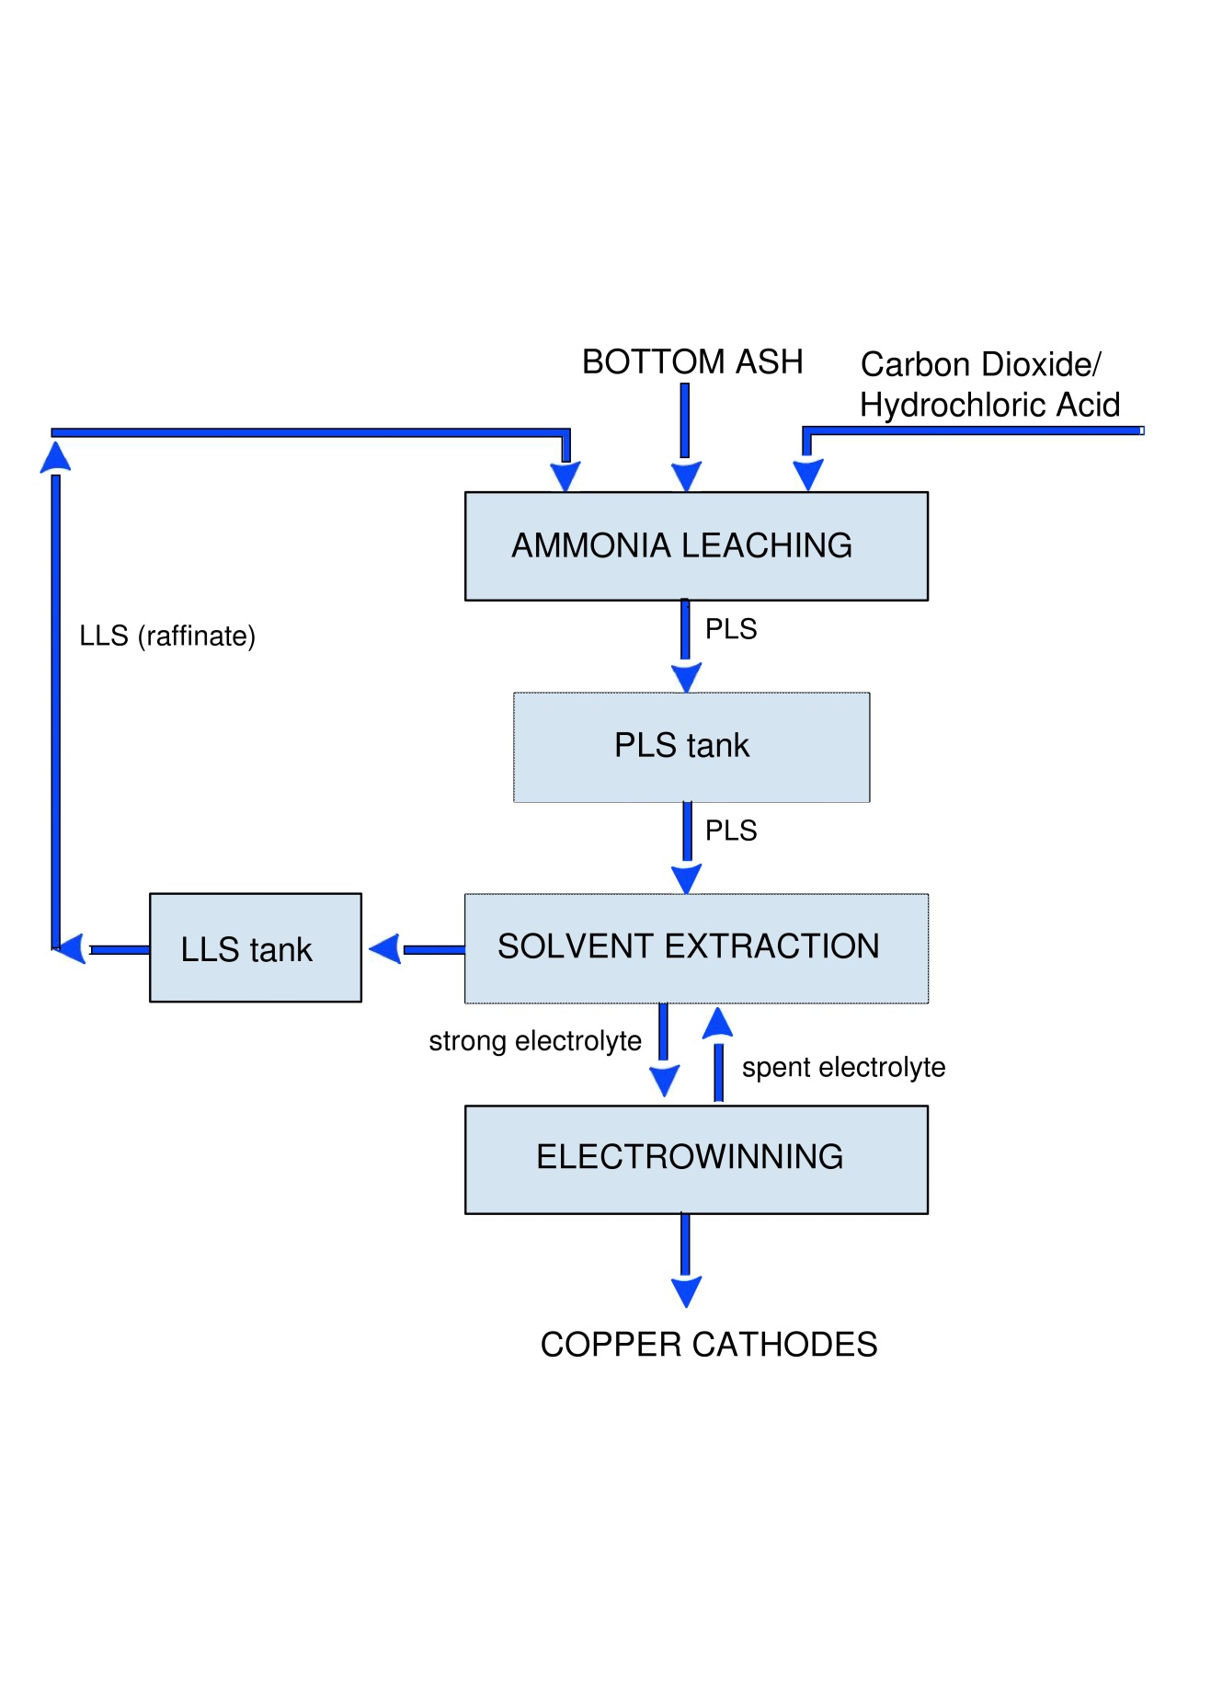

Figure 1: Ammonia Process Simplified Flowsheet

PLANT OPERATIONS

Leaching

Two tests were performed during a total testing period of 6 months at Attero, Deurne. Two types of bottom ash were tested. The operating conditions were based on prior tests from the Moerdijk Netherlands column pilot plant and adjusted when required during the tests: an ammonia solution, optimized pH and oxygen addition.

During test 1, the tunnel was filled with the integral fraction (0-40mm) of de-ironed, processed bottom ash from the Moerdijk waste-to-energy plant. During the second test, the tunnel was filled with the integral 0-40mm fraction, fresh and un-processed ash from the Moerdijk waste-to-energy plant.

The pilot plant consists of one leaching tunnel with a depth of 30 meters and a height and width of both of 4 meters. The tunnel was filled up to around 3 meters high by shovels, resulting in 450 tonnes of dry ash processed per batch. The leach solution was percolated from the top of the tunnel through distribution nozzles at a flow rate of between 65 and 80 L/min/h. The leaching liquid was collected at the bottom of the heap, through a spigot floor. The spigot floor consists of small holes in the floor, which end in large liquid collection pipes that guide the liquid towards the far end of the tunnel. From there, the liquid was pumped towards a large buffering pond. When the concentration of the copper in the pond was high enough, it was fed to the SX/EW plant.

Operating Parameters

The main operating parameters are presented in Table 1.

Table 1: Operating Parameters

|  |  |  |
| --- | --- | --- |
| Parameter | Test 1 | Test 2 |
| Ammonia concentration in the leach solution, g/l | 60 | 60 |
| Irrigation rate, L/h/m2 | 6-8 | 6-8 |
| pH in the leach solution | 11.2 | 11.05 |
| pH adjustment in the leach solution | CO2 | HCl |

Solvent Extraction

The SX circuit consists of 4 (four) mixer-settler units: 1 (one) extraction stage, 2 (two) wash stages and one (1) strip stage. SX flowsheet is shown in Figure 2.

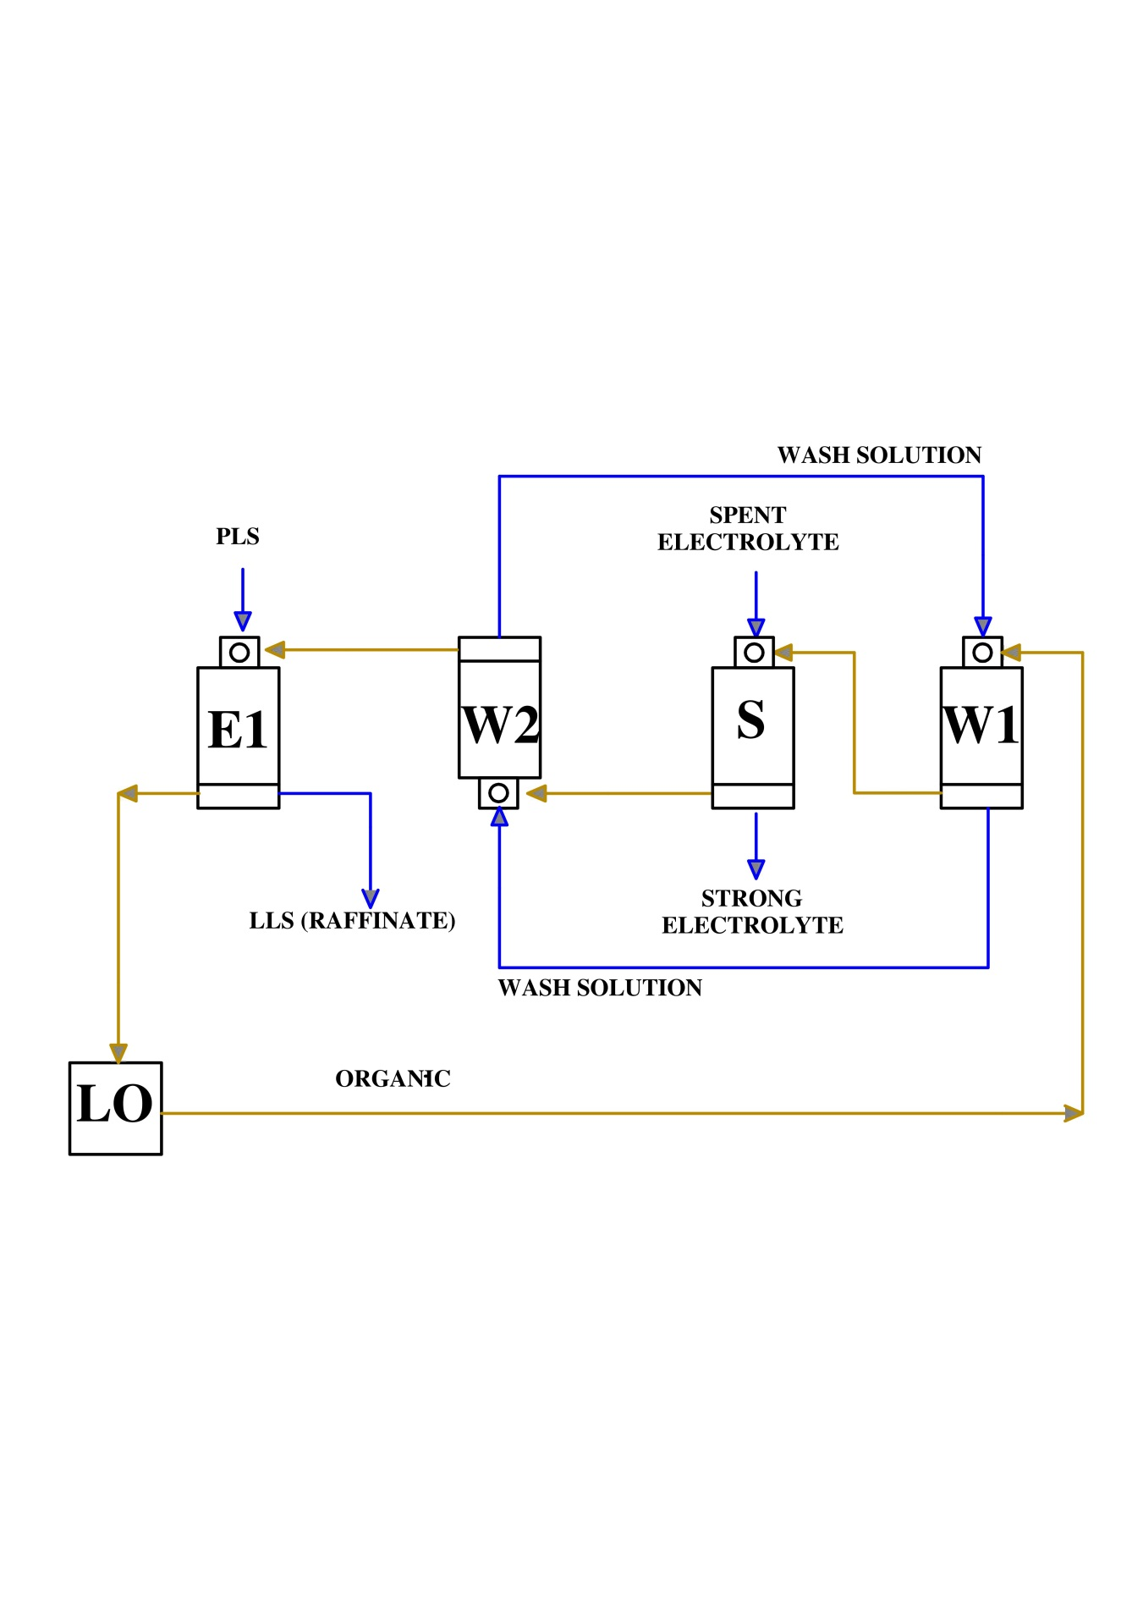

Figure 2: SX Circuit Configuration

Extraction Stage

The ammonium leach liquor, with the copper removed, was the feed to the solvent extraction circuit. Pregnant leach ssolution (PLS) was pumped at 2.6 m3/h to the extraction mixer-settler. The mixer was operated in aqueous continuous mode to maintain a reasonable disengagement time of aqueous and organic in the settler. The tenor of the PLS was an average concentration of 2.0 g/l Cu at pH=11 and average ammonia concentration of 35 g/l. In this stage, the PLS was contacted with an organic copper extractant LIX 84-I (ketoxime type) with 10 vol.% concentration, which was diluted with Escaid 120. After phase disengagement raffinate and loaded organic were obtained. The latter was pumped to a Loaded Organic Tank (LOT) to assist in removal of entrained aqueous. The raffinate went to a flotation column to remove any entrained organic, then discharged to the Raffinate tank and recycled to the leaching. An organic to aqueous ratio (O:A) of 1:2 through the extraction stage, was maintained. The ratio within a stage was altered by recycling a portion of the organic phase.

Operating Parameters

The operating parameters used in the extraction circuit are given in the following table:

Table 2: Operating Parameters

|  |  |
| --- | --- |
| Parameter | Value |
| SX Aqueous feed flow rate, m3/h | 2.6 |
| Organic flow rate, m3/h | 1.3 |
| Recycle (organic), m3/h | 1.0 |
| O:A advance flow ratio | 1:2 |
| O:A in mixer | 1:1.1 |
| Contact time per each mixer, min | 3.0 |
| Mixer phase continuity | Aqueous |
| Method of organic recovery from raffinate | Flotation column |
| Method of aqueous recovery from organic | LOT drain |

Wash Stages

Due to the high concentrations of ammonia and chlorides in the feed solution, co-extraction of ammonia and chloride occurred. The loaded and stripped organic were washed in two stages in order to perform both chemical and physical washing of impurities from the loaded organic before it entered the strip stage and neutralize acidified organic from strip stage before it was recirculated back to the extraction stages.

Following extraction, a low acid wash stage (W1) was used to remove entrained ammonia and impurities from the organic phase. The copper-loaded organic from the LOT was pumped to W1 where it was contacted with acidic water. The wash stage used demineralized water as the wash liquor acidified by dosing 95% H2SO4 into the tank and then into the mixers. The aqueous solution was kept at a reasonable pH, about pH=2-2.5 and a sulphuric acid concentration 2 g/l.

Following copper stripping, the stripped organic phase was subjected to the other stage of washing (W2) with the resultant aqueous W1 at approximately pH=3. A weak acid solution was generated by contacting the stripped organic in W2 wash stage to remove entrained acid and this weakly acidic W2 aqueous was fed to W1.

To optimize mixer organic-to-aqueous volumetric ratios (O:A), aqueous recycles were employed. The advance O:A ratio in the washing stages was 4.3:1, but an internal ratio of 1:1 was maintained by recirculating a portion of the aqueous phase. The stripped organic after W2 was sent to the extraction stage where it was again contacted with PLS to extract copper.

Operating Parameters

Operating parameters for the wash stages are given in Table 3.

Table 3: Operating Parameters

|  |  |
| --- | --- |
| Parameter | Value |
| Aqueous feed to wash, m3/h | 0.3 |
| Organic flow rate, m3/h | 1.3 |
| Recycle (aqueous), m3/h | 1.0 |
| pH Wash solution | 2-2.5 |
| O:A advance flow ratio | 4.3:1 |
| O:A in mixers | 1:1 |
| Contact time per each mixer min | 3.0 |
| Mixer phase continuity | Aqueous/Organic |
| Method of aqueous recovery from organic | After-settlers |

Strip Stage

In a single mixer settler stripping stage the washed organic was stripped of copper by contacting with spent electrolyte recycled from the electrowinning. The spent electrolyte contains approximately 40 g/l copper and 175 g/l sulphuric acid and removes the copper from the organic phase into the aqueous phase. The electrolyte leaving the stripping is called strong electrolyte and contains approximately 50 g/l copper and 160 g/l acid. The advance O:A ratio in stripping was 2:1, but an internal ratio of 1:1 was maintained within the stripping stage by re-circulating a portion of the aqueous phase.

The filtered strong electrolyte was stored in a tank for strong and spent electrolyte. The strong electrolyte solution was heated in a heat exchanger by spent electrolyte returning to the strip mixer settler. Then the electrolyte was pumped to the electrowinning cells in the electrowinning area (EW). The mixer of the strip stage was run under organic continuous phase continuity to minimize organic losses to the aqueous outlet stream.

Operating Parameters

Operating parameters for the strip stage are presented in Table 4.

Table 4: Operating Parameters

|  |  |
| --- | --- |
| Parameter | Value |
| Aqueous Feed to strip section, m3/h | 0.65 |
| Organic flow rate, m3/h | 1.3 |
| Recycle (aqueous), m3/h | 0.65 |
| O:A advance flow ratio | 2:1 |
| O:A in mixers | 1:1 |
| Contact time per each mixer, min | 3.0 |
| Mixer Phase Continuity | Organic |
| Method of organic recovery from strip | Flotation column, Dual media filter |
| Method of aqueous recovery from organic | After-settler |

Electrowinning

The heated electrolyte with flow rate 1.5 m3/h was fed to 4 EW cells, each containing 9 cathodes and 10 anodes. In the EW cells the electrolysis process deposits copper onto permanent stainless steel cathodes, releases oxygen at the lead anodes, and increases the sulphuric acid concentration of the electrolyte.

After the EW-cells the spent electrolyte flows to the strong and spent electrolyte tank. There the spent electrolyte heats the incoming strong electrolyte to minimize heat loss. The spent electrolyte was returned to the stripping stage.

The EW cells were equipped with covers and a scrubber system to capture the acid mist caused by the evolution of oxygen gas at the anode.

Operating Parameters

Operating parameters for the electrowinning are presented in Table 5.

Table 5: Operating parameters

|  |  |
| --- | --- |
| Parameter | Value |
| Electrolyte flow rate, m3/h | 1.5 |
| Current density, A/m2 | 300 |
| Cobalt dosing, ppm | 120 |
| Guar dosing, kg/t copper | 0.2 |
| Cell operating temperature, 0C | 42 |

PILOT PLANT RESULTS

Feed Material

The bottom ashes used for the two tests are shown in Table 6.

Table 6: Feed material characteristics

|  |  |  |
| --- | --- | --- |
|  | **Test 1** | **Test 2** |
| Source Ash | Moerdijk | Moerdijk |
| Bottom ash type | Processed | Fresh |
| Fraction, mm | 0-40 | 0-40 |
| Treated Bottom ash (wet), tonnes | 520.02 | 565.62 |
| Treated Bottom ash (dry), tonnes | 442.02 | 469.46 |
| Moisture content, w% | 15 | 17 |

Key Metallurgical Results

Table 7 presents pilot plant metallurgical results.

Table 7: Key Metallurgical Results

|  |  |  |
| --- | --- | --- |
|  | **Test 1** | **Test 2** |
| SX copper recovery, % | 91.4 | 92.2 |
| EW current efficiency, % | 95.0 | 95.0 |
| Cathode Quality | LME Grade A | LME Grade A |

CONCLUSIONS

The Atero/Elemetal - Solvent Extraction/Electrowinning (A/E-SXEW) pilot plant located in the Netherlands demonstrated successful piloting of the solvent extraction process for copper recovery from ammonia leach solutions. Two types of bottom ash have been tested in the pilotprogram. The results indicate that, on average, 92% of the copper are extracted during the selective process and, subsequently, are recovered as high purity copper cathode with quality LME Grade A (99.999% Cu).

The pilot plant duration was 6 months in order to obtain sufficient data to be used in the development of process design criteria, flowsheet development and equipment selection.

The results from the pilot plant will be used for design and scale up to a commercial L/SX/EW plant.

ACKNOWLEDGMENTS

The authors would like to thank the staff and management of the Attero and Elemetal for their collaboration and provision of data to prepare this paper. The views of the authors do not necessarily present those of the Companies.

REFERENCES

1. Karlfeldt Fedje, K., Ekberg, C., Skarnemark, G., Steenari, B.-M., 2010. Removal of hazardous metals from MSW fly ash - An evaluation of ash leaching methods. Journal of Hazardous Materials 173, 310-317.
2. Van der Sloot, H.A., Kosson, D.S., Hjelmas, O., 2001. Characteristics, treatment and utilization of residues from municipal solid waste incineration, Waste Management 21, 753-765.
3. Zhang, H., He, P.-J., Shao, L.-M., Li, X.-J., 2008. Leaching behavior of heavy metals from municipal solid waste incineration bottom ash and its geochemical modeling. J Master Cycles Waste Manage. 10, 7-13.
4. [Arickx S](http://www.ncbi.nlm.nih.gov/pubmed/?term=Arickx%20S%5BAuthor%5D&cauthor=true&cauthor_uid=17531463), [Van Gerven T](http://www.ncbi.nlm.nih.gov/pubmed/?term=Van%20Gerven%20T%5BAuthor%5D&cauthor=true&cauthor_uid=17531463), [Knaepkens T](http://www.ncbi.nlm.nih.gov/pubmed/?term=Knaepkens%20T%5BAuthor%5D&cauthor=true&cauthor_uid=17531463), [Hindrix K](http://www.ncbi.nlm.nih.gov/pubmed/?term=Hindrix%20K%5BAuthor%5D&cauthor=true&cauthor_uid=17531463), [Evens R](http://www.ncbi.nlm.nih.gov/pubmed/?term=Evens%20R%5BAuthor%5D&cauthor=true&cauthor_uid=17531463), [Vandecasteele C](http://www.ncbi.nlm.nih.gov/pubmed/?term=Vandecasteele%20C%5BAuthor%5D&cauthor=true&cauthor_uid=17531463)., 2007. Influence of treatment techniques on Cu leaching and different organic fractions in MSWI bottom ash leachate. [Waste Manag.](http://www.ncbi.nlm.nih.gov/pubmed/17531463) 27(10), 1422-7.
5. Van Gerven, T., Cooreman, H., Imbrechts, K., Hindrix, K., Vandecasteele, C., 2007. Extraction of heavy metals from municipal solid waste incinerator (MSWI) bottom ash with organic solutions. Journal of Hazardous Materials 140, 376-381.
6. Radmehr, V., Koleini J.M.S., Khalesi, R.M., Tavakoli Mohammadi, R.M., 2012. Ammonia leaching in the copper industry: a review. XXVI International Mineral Processing Congress (IMPC) Proceedings/New Delhi, India /24-28 September 2012, Paper No. 487, 02512-02523.